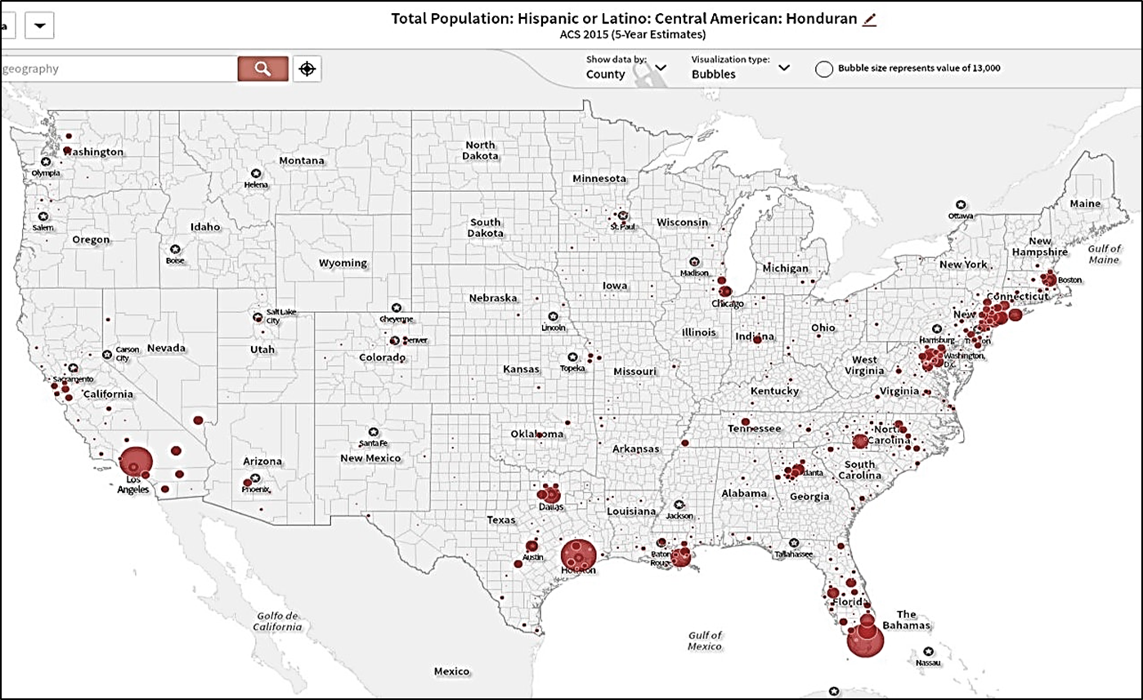
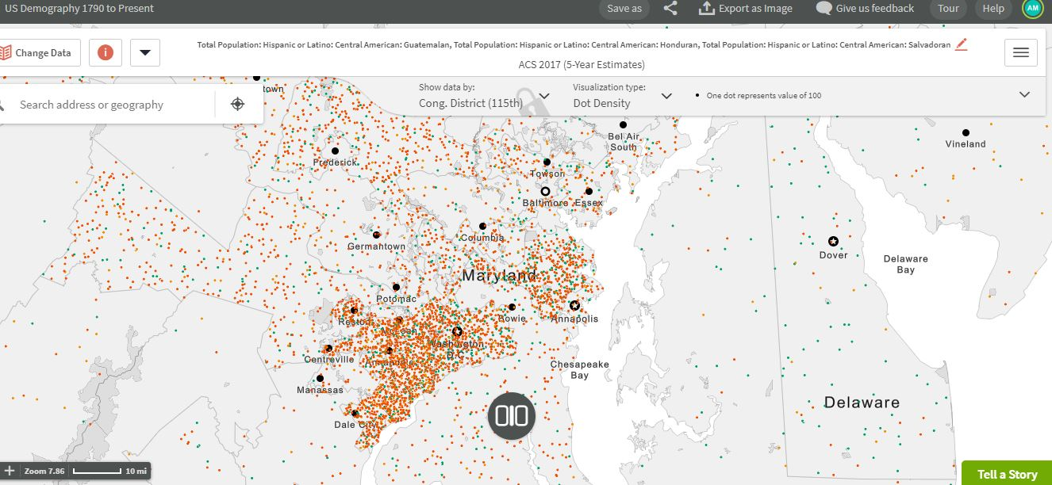
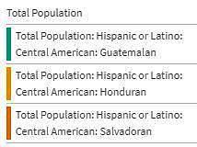
Total Population by Northern Triangle Origin in Washington DC Area

El Salvador – 291,334

Honduras – 50,032

Guatemala – 70,922
DC Delegate  Eleanor Holmes Norton - D | MD-District 3  John Sarbanes - D | MD-District 4  Anthony Brown - D | MD – District 5  Steny Hoyer - D
MD – District 7  Elijah Cummings - D | MD -District 8  Jamie Raskin - D | VA – District 1  Rob Montross - R | VA – District 8  Don Beyer - D
VA – District 10  Jennifer Wexton - D |  | VA – District 11  Gerry Connolly - D
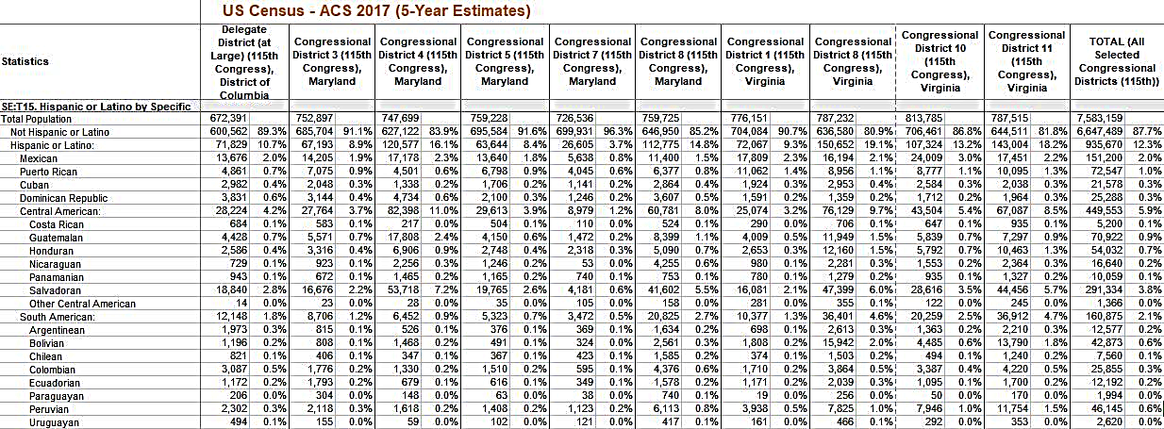
DC Delegate  Eleanor Holmes Norton – D  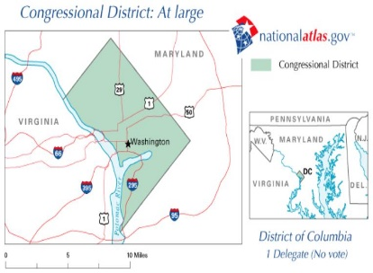 | MD-District 3  John Sarbanes – D  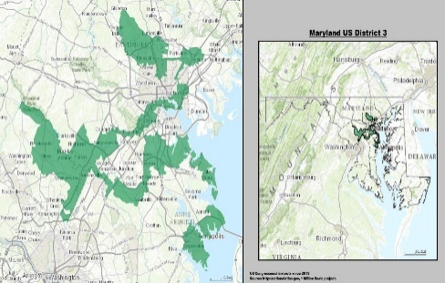 | MD-District 4  Anthony Brown – D  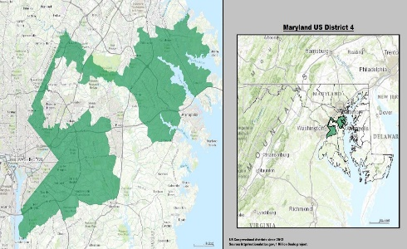 | MD – District 5  Steny Hoyer – D  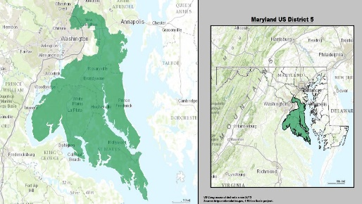
MD – District 7  Elijah Cummings – D  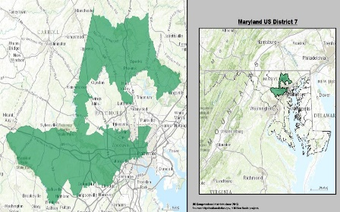 | MD -District 8  Jamie Raskin – D  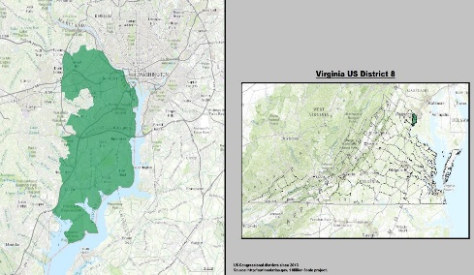 | VA – District 1  Rob Montross – R  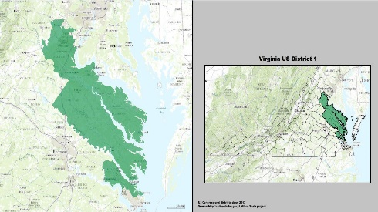 | VA – District 8  Don Beyer – D  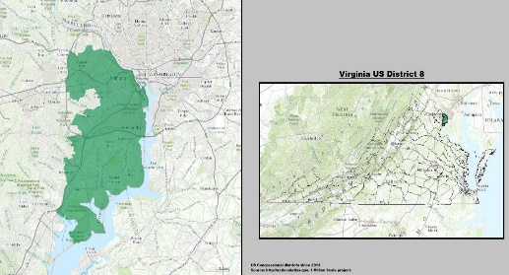
VA – Destricé 10  Jennifer Wexton – D  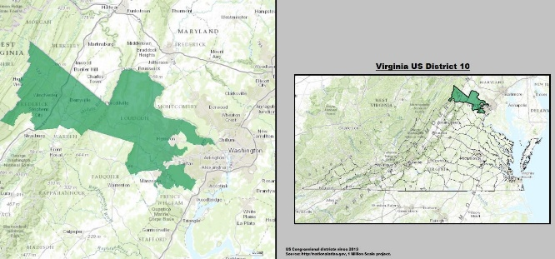 |  | VA – District 11  Gerry Connolly – D  