Trip Report
Visit to the Central Euphrates Farmers Market (CEFM) Site
Michael Maxey, USAID Rep. ePRT North Babil
September 14, 2008

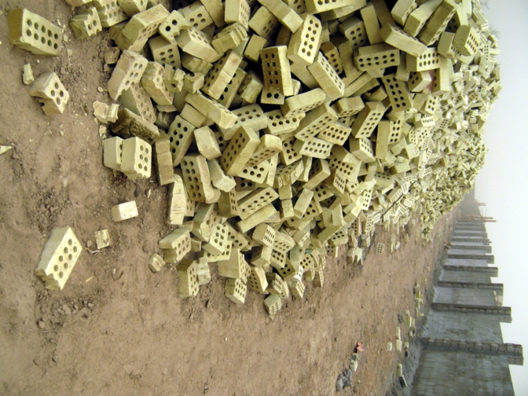
Visited the site of the CERP funded $3.2 million CEFM to observe construction progress and discussion operation of the farmers market with local ag association leaders. The ag association leadership was not at the site but we had a chance to talk to the contractor who explained that all the labor being used was local and that all the material that could be sourced locally was being purchased in the area (sand, gravel, etc.). The bricks to be used in construction were purchased near Baghdad. A quick description by the contractor indicated that the market would have 40 stalls, 30 shops/offices, 120 car parking lot, support building (420M² area) and four guard towers. The entrances are located on the road side and there will be security gates to prevent car bombs.

This facility will provide a market for up to 10,000 farmers in the region. It’s major advantage is its location on a sectarian fault line with relatively equal population mix on both sides – Sunni and Shia. This allows both groups to come to the market in a relatively safe environment. EPRT North Babil is working to develop an operations plan and business plan for the ag associations that will own and manage the market. | 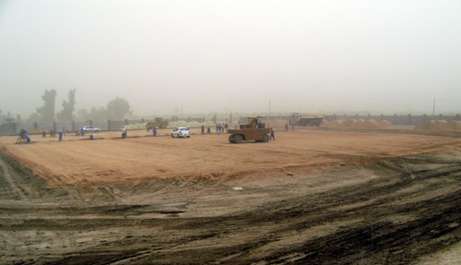
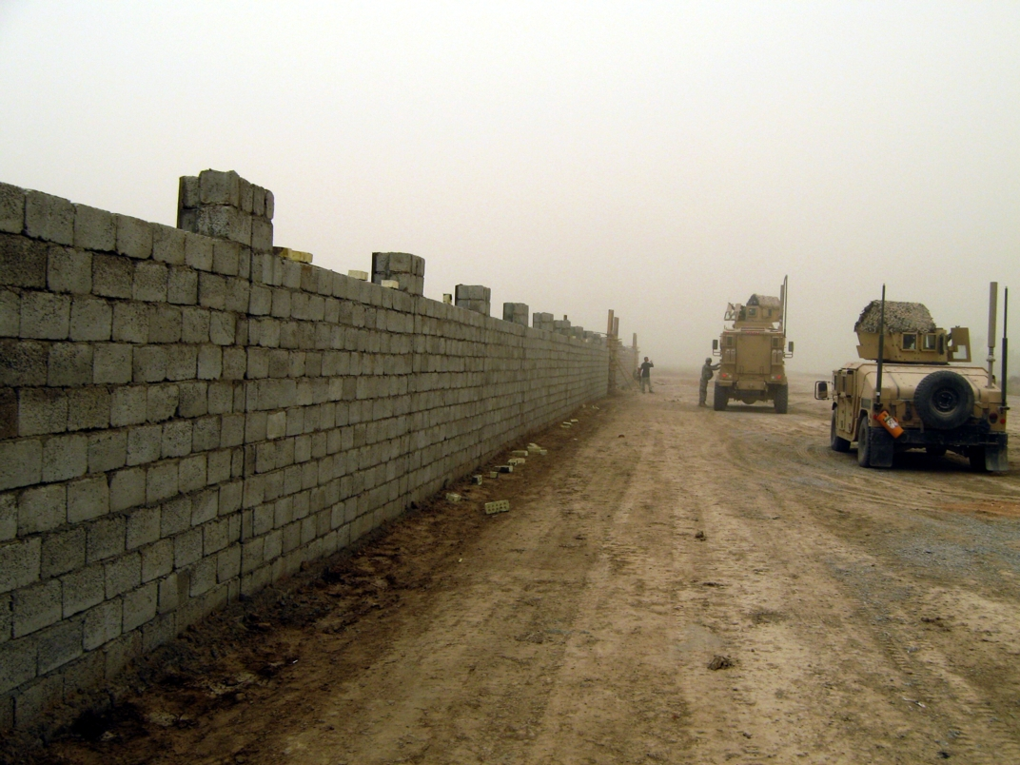
One of the problems facing the farmers’ market at this point is the perception in the community that this is a facility for other purposes (government facility, detention center, etc.). This perception has to be changed. One thing we discussed during the trip was the need for a sign in front of the market explaining in Arabic what it is and how it will be operated.

