Think Piece: Honduran Guest Worker Housing Program &
Remittance Bond for Small Business Development
Michael Maxey (Michael@Maxey.Info)

A Guest Worker Program for undocumented Hondurans in the US could positively engage with the region in a win/win approach that resolves a major immigration issue while simultaneously strengthening the Honduran economy. By bringing home a large segment of the diaspora to help rebuild Honduras, this concept would spur economic development, provide new skills to national labor force, and spur innovation and new enterprises.

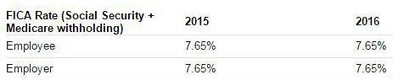
The linchpin of this approach would be a legal mechanism – a Guest Worker Program - for undocumented Hondurans in the US to work, save, and voluntarily emigrate back home. This program would be a counterbalance to proposed "penalty actions" of strengthening e-verification employment requirements, eliminating social welfare benefits, and increased stop and hold efforts. So instead of forced deportation of 350,000 undocumented Hondurans, the USG under a Guest Worker Program would allow workers to contribute 7.65 percent of their wages to a “Housing Fund” matched with a 7.65 percent contribution by their employer (this equivalent to the current FICA and Medicare tax already contributed by workers).

A married couple working 4 years in a guest worker program at $8 per hour and 40 hours per week could accumulate over $20,000 in a housing fund. The fund would only be available to the couple upon a return to Honduras. The potential accumulation of housing funds by the Honduran labor force in the US (which is estimated to be 252,000) would be $2.6 billion. This housing fund could be used to revitalize the construction sector in Honduras creating new jobs and as a policy leverage to create a vibrant secondary mortgage market.
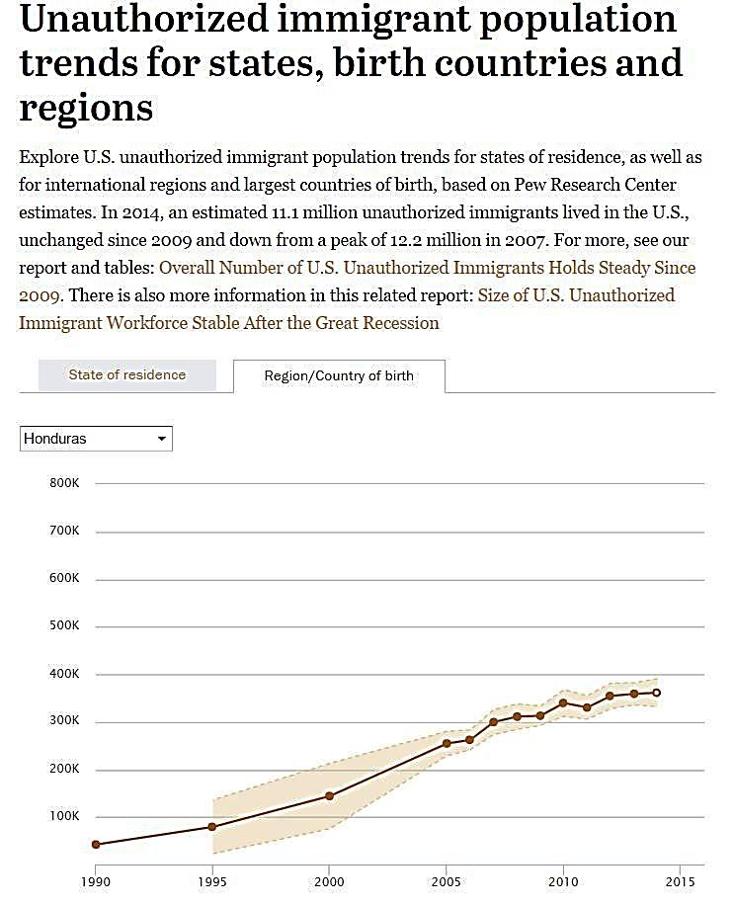
​ Remittance Bond for Small Business Development
Unauthorized immigrant population trends for states, birth countries and regions, Pew Hispanic Center. See http://www.pewhispanic.org/interactives/unauthorized-trends/
Honduran Unauthorized Population in the US is estimated to be more than 350,000 with 70% in the US labor force.

​In the same vein as the housing fund, Instead of taxing remittances, the US could establish a matching fund for guest workers who want to dedicate a portion of their remittances to a "small business fund." A 1 to 3 match with the USG providing 1 dollar for every 3 from the guest worker could create a nest egg for a small business in their home country with the funds only to be released when they return home. The US could link these entrepreneurs to USAID financed programs for training, technical assistance and mentoring. This approach is much better than trying to stop remittances or tax them in some way -- the World Bank estimates that Hondurans sent remittances in 2015 that were equivalent to almost 18% of GDP ($3.6 billion in remittances versus total GDP of $20.1 billion).

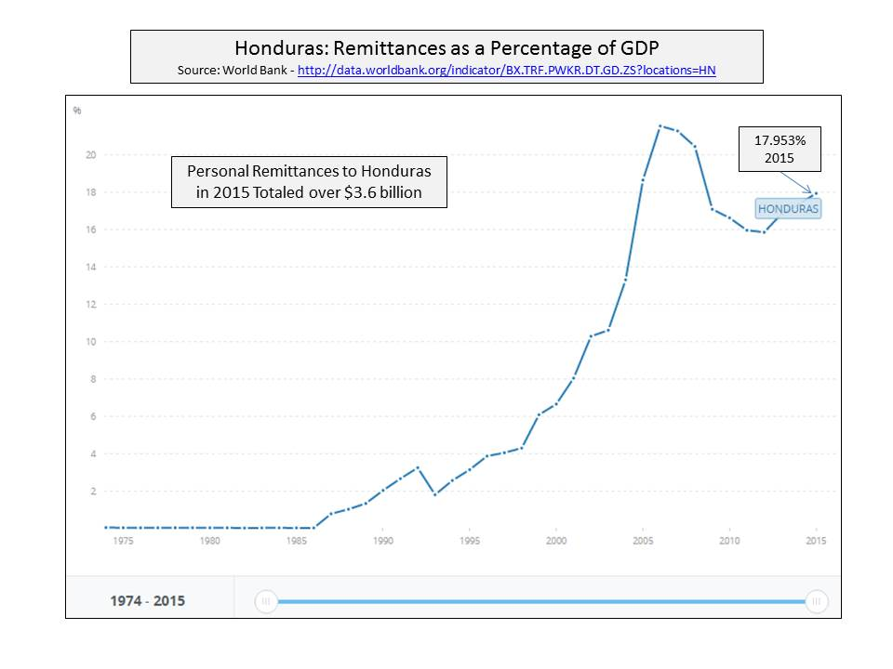
Honduras has one of the largest informal sectors in the hemisphere -- according to the ILO, over 70% of all non-agricultural jobs are informal. Research indicates that informality can be addressed through investment in small businesses. The key to gaining access to capital for business startups could be through the reform of the secondary mortgage​ market so that real estate could be used as collateral for financing. The use of personal real estate as collateral in the US facilitates one of the major sources of financing of small businesses in the US.

The Honduras labor force is estimated to be 252,000 or 72% of the 350,000 undocumented Hondurans. Source: Pew Hispanic Center.
World Bank definition of remittances: “Personal remittances comprise personal transfers and compensation of employees. Personal transfers consist of all current transfers in cash received by resident households from nonresident households. Compensation of employees refers to the income of border, seasonal, and other short-term workers who are employed in an economy where they are not resident and of residents employed by nonresident entities.”
At 72.8%, Honduras has the second highest informal employment rate in the hemisphere. This is the rate of non-agricultural informal jobs as a percentage of total employment. Guatemala has the highest rate at 73.6%. See http://www.as-coa.org/articles/weekly-chart-latin-americas-informal-economy.
See http://www.rrojasdatabank.info/sida.pdf -- Enhancing access to capital – 1 of 4 key intervention areas. See p.24.
Over 51% of entrepreneurs reported bank loans as one of the key means of access to capital. See http://www.kauffman.org/what-we-do/resources/entrepreneurship-policy-digest/how-entrepreneurs-access-capital-and-get-funded

