North Babil ePRT AG Team

The Economic Importance of Building a New Centrally Located
Central Euphrates Valley Farmers Market and Agricultural Center
In The Northern Portion of Babil Province

By

George Stickels, North Babil ePRT AG Advisor & Agricultural Economist
&
Dr. Fouad Hussein, North Babil ePRT BBA & Agricultural Economist

An Economic Study

From July, 2007, through February, 2008, the AG Team of the North Babil ePRT, comprised of George Stickels, AG Advisor, and Dr. Fouad Hussein, Bilingual Bicultural Advisor (BBA) and economist, conducted an economic study regarding the need for and the benefits to be derived from the construction of a modern farmers market and processing facility, combined with an agricultural center, in the central corridor of the northern part of Babil Province, Iraq. The results of that study form the basis for this paper which is in three parts. The first part provides a proposal summary intended to serve as a vehicle for the consideration of multiple funding sources. The second part is a narrative that provides more detailed information about the area and the proposal. The third part is a separate document that provides specific economic data about the area’s agriculture in Excel tables and charts. Also attached are addenda that provide additional information related to the project.
Table of Contents

Part I – Proposal Summary . . . . . . Page 3

Part II – Proposal Narrative . . . . . . Page 4

1. Introduction . . . . . . . Page 4
2. Facts about the Area and Its Supply-Demand Imbalance . Page 4
3. How Area’s Demand and Supply Were Determined . . Page 5
4. How Area’s Total Planted Donum Were Determined . . Page 6
5. Farmers Market Purpose . . . . . Page 7
6. Parties to the Market MOA and Their Roles . . . Page 8
7. Both a Modern Market and an Agricultural Center . . Page 8
8. Market Site Selected . . . . . . Page 9
9. Market Site Photo . . . . . . Page 10
10. Importance of the CEFM’s Location . . . . Page 10
11. Market Construction Phases . . . . . Page 11
12. Estimated Cost of Market Phase 1 . . . . Page 12
13. General Layout of the Market Phase 1 . . . . Page 12
14. Marketplace Floor Plan Phase 1 . . . . Page 13
15. Building Capacity in Phases . . . . . Page 13
16. Value-Added Food Chain Processing in Subsequent Phases . Page 14
17. Training and Employment Opportunities During Construction . Page 14
18. Extension Programs and Experimentation . . . Page 15
19. Non-Sectarian and Non-Discriminatory Policies . . Page 15
20. Study Conclusions and Recommendations . . . Page 16

Part III – Economic Data in Tables and Charts (Separate Document) Page 18

Supply Table 1, Vegetables . . . . . . Page 1
Supply Table 2, Grains, Oilseeds & Grasses . . . Page 1
Supply Table 3, Fruit . . . . . . . Page 2
Supply Table 4, Livestock, Fish Farms, Bee Keepers & Dairy . Page 2
Table 5, Supply & Demand in Metric Tons . . . . Page 2
Table 6, Consumption & Production Seasons . . . Page 2
Table 7, Tillable Land by Commodity . . . . Page 3
Supply Chart I, Primary Vegetable Production . . . Page 3
Supply Chart II, Secondary Vegetable Production . . . Page 4
Supply Chart III, Primary Crop Production . . . . Page 4
Supply Chart IV, Secondary Crop Production . . . Page 5
Supply Chart V, Fruit Production . . . . . Page 5
Supply Chart VI, Livestock per AG Association . . . Page 6
Supply Chart VII, All Livestock . . . . . Page 6
Supply Chart VIII, Milk Production . . . . . Page 7
Chart IX, Tillable Planted Land . . . . . Page 7
Chart X, Supply & Demand for Major Commodities . . Page 8

Addendum 1, Memorandum of Agreement . . . . Page 19
Addendum 2, Planting and Harvest Dates . . . . Page 22
Addendum 3, Persons Interviewed During Economic Study . Page 23

Part I – Proposal Summary

Title: Central Euphrates Farmers Market (CEFM) & Agricultural Center

Location: To be built in north central Babil Province on Highway Tampa.

Amount: Estimated cost of constructing CEFM Phase 1 is $3,200,000.

Problem: The North Babil area is agricultural with over 10,000 farmers now raising crops there. Yet much of its farmland is unused for various reasons, and consequently area demand significantly exceeds area supply. No modern central market exists in the area for bulk sales, although studies confirm that the existence of such a market would do much to encourage increased area production and area land reclamation. Area AG Associations want to build and operate a market and AG center but they have been unable to secure funding for such a large project on their own.

Solution: Coalition Forces (CF) at FOB Kalsu, led by the North Babil ePRT, have joined the CEFM effort. They have partnered with area AG Associations and are assisting with CEFM design and its Scope of Work, and they are seeking funding for its construction.

Objectives: CEFM will help generate increased agricultural production in the area; help to reclaim tillable land that lies fallow due to overuse, neglect or the adverse affects of salinity buildup; help to educate local farmers in modern agricultural practices; help to encourage and facilitate food chain value-added processing capacities; help to train area unskilled laborers in construction skills; help to provide facilities for agricultural experimentation; and provide jobs.

Ownership: CEFM will be owned by participating AG Associations jointly.

Operation: CEFM will be operated and managed by AG Associations jointly.

Beneficiary: Farmers and consumers throughout the Central Iraq region.

Timeline: Construction should begin NLT May 1, 2008, and be completed NLT September 1, 2008.

Brief History: In late 2006, Civil Affairs (CA) Teams envisioned this market as being simply a field near FOB Kalsu where farmers, with limited fuel, could safely gather and sell produce loaded on Bongo trucks wholesale to distant market buyers. As area security improved the CEFM bulk sales concept grew to become an ePRT project.
A MOA was signed 10-24-07. A site agreement was reached
1-5-08. A Scope of Work was completed 1-19-08. Bids have been received and first contractor CA presentation was 2-22-08.

Part II – Proposal Narrative
1. Introduction

Agriculture is a large sector of the economy of the northern Babil Province area. However, current agricultural production in the area is only a fraction of its true potential. This economic study -- for this proposal -- concluded that programs are needed that focus both on revitalizing the area’s agricultural productive capacity and on building marketing capacity. The bulk sales Market advocated herein will be built over time in phases. The first phase, the marketplace itself, would cost about $3.2 million. Design work for Phase 1 has been done, and bids have been received. Design finalizing, securing funds and contact award remain.

2. Facts about the Area and Its Supply-Demand Imbalance

The total population of Babil Province is estimated to be 1,408,730. The northern area of the Province, with an estimated population of 400,000, consists of these (8) Model Communities as identified by Coalition Forces based at FOB Kalsu: Muelha; Jiff Jaffa; al Haq; Diyarah; Tunis; Jurf as Shakr; Abuloach; and Khadir. In those Model Communities there are approximately 10,000 farmers who actively farm an estimated 233,888 donum. Some of the area’s agricultural production is sold in crowded urban markets in Tunis, Mussyyib or Iskandariyah, but bulk produce is hauled to distant markets in Hilla, Kerbala and Baghdad. The Model Communities have no centrally located bulk wholesale-retail market.

Most of the productive farmland in northern Babil Province is irrigated by traditional flood irrigation. Yet more than half of the area’s total farmland, estimated now to be between 500,000 and 600,000 donum, is not used -- land once tillable but now unusable -- due either to lack of water, poor drainage, salinity buildup, inadequate fertilizing, or simply years of warfare and insecurity that have robbed the area of much of its agricultural human capital. Much of this now unusable land has degraded to the point that reclaiming it for farming will be a huge task. Statistics about unused farmland in northern Babil Province are striking similar to those of national studies conducted in Iraq by the Food and Agriculture Organization (FAO) of the U.N. For example, the FAO estimates that less than half of Iraq’s 32 million donum of agricultural land is cultivated annually.

The economic realities that result from the area’s high rate of unused farmland and its lack of an accessible wholesale-retail market are, (1) over time the growth of area demand, relative to limited area supply, has driven area food prices up; and (2) increased food prices have prompted a large flow of agricultural imports from neighboring countries. In short, the area has a supply-demand imbalance.

Additionally, the area’s productive capacity is constrained by the fact that area farmers do not have the ability to obtain modern farm equipment, and they do have the ability to implement modern, efficient irrigation systems.

The area’s supply-demand imbalance is confirmed by statistics determined by Dr. Hussein during this economic study. For example, on average, northern Babil Province now produces only 46 percent of the tomatoes, eggplant, dates and milk it consumes; it produces only 28 percent of the watermelons it consumes; it produces only 14 percent of the potatoes and yellow corn it consumes; and it produces less than 10 percent of the wheat and barley it consumes. For specific data on these production-consumption comparisons see Part III, Table Number 5, and Chart X.

More significantly, given the potential productive capacity of farmland in northern Babil Province, the area should not only be meeting its local agricultural needs, it should be greatly exceeding them and exporting its agricultural production. But the last time Iraq exported any agricultural commodities was before the Iraq-Iran War that began in the early 1980’s.

3. How Area’s Demand and Supply Data Were Determined

The “demand” data determined by this economic study are based on minimum daily (per capita) nutritional needs of people in this region of the Middle East. For more specific information about assessments of this area’s nutritional needs go to: http://faqs.org/nutrition/Met-Obe/Nutritional-Assessment.html

The “supply” data determined by this study (see Part III) result from in-depth interviews conducted by Dr. Hussein with area farmers and AG leaders, and albeit less scientifically, from helicopter observations that visually confirm large portions of farmland are unused due to poor drainage or salinity buildup. For example this 3-29-08 photo shows area farmland idled by poor drainage.

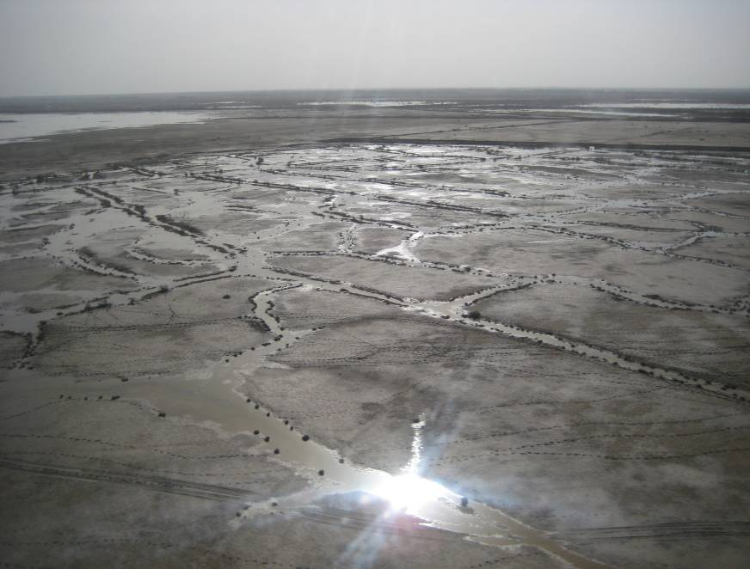

This 2-6-08 photo shows North Babil area farmland that has been idled by salinity buildup so excessive it appears to be a dusting of snow.

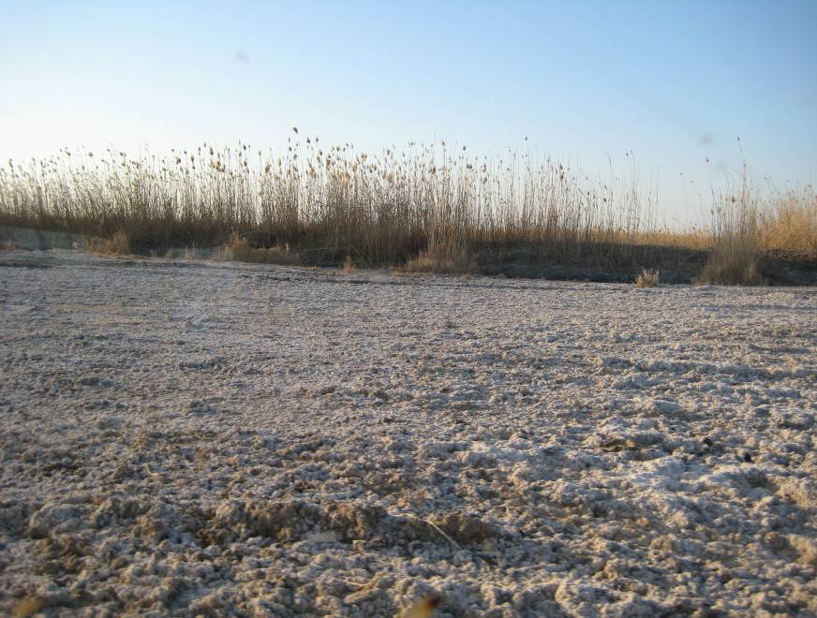

4. How Area’s Total Planted Donum Were Determined

The “planted donum” data determined by this study (see Part III) result from interviews conducted by Dr. Hussein with CEFM participating AG Association leaders. Dr. Hussein then statistically adjusted the 127,000 usable donum determined during his interviews to calculate the area’s total 233,888 planted donum, which is comprised of:

- 31,170 donum of vegetables (potatoes, cucumbers, okra, lettuce, roman beans, tomatoes, zucchini, eggplant, peppers and green beans)

- 56,858 donum of grains, oilseeds and grasses (wheat, barley, oats, sesame seeds, yellow corn, corn for animal feed)

- 43,860 donum of fruit (dates, watermelon, honeydew, cantaloupe).

Note: Iraq has two growing seasons, Winter (October through March), and Summer (April through September). In Part III of this study, vegetables classified as Primary Vegetables are tomatoes, eggplant and potatoes; Secondary Vegetables are cucumbers, roman beans, zucchini, lettuce, okra and peppers. Grains, oilseeds and grasses classified as Primary Crops are wheat, barley and yellow corn; and Secondary Crops are feed corn, alfalfa, sesame seed and oats.

For data on area “planting” and “harvest” times see the table in Addendum 2.

5. Farmers Market Purpose

To address the area’s supply-demand imbalance problem, AG leaders in its Model Communities have taken proactive and cooperative intercommunity leadership roles designed to enhance the farm sector of the area’s economy. They desire to build a modern bulk sales market and agricultural center in the center of the region, and they remain confident, in spite of the degradation of much of the area’s farmland, that the region’s farm economy remains diversified and can again become highly productive given incentives such as the CEFM.

They realize better than anyone that no modern farmers market exists along Highway Tampa, the main north-south corridor (Mosul to Baghdad to Basra) that runs through the center of this farming region. They also understand that area buyers and sellers have no centrally located place to gather and transact bulk sales, and that they are now forced to truck their bulk produce long distances to markets either to the west, or north to Baghdad, or south to Hilla or Kerbala.

On their own they have met with local bankers to seek funding for such a market venture. But they are stymied. They have neither the credit history required to borrow the amount needed for the project, nor the ability to repay a loan of that size.

So to address this need, Coalition Forces based at FOB Kalsu, more specifically the North Babil ePRT, have formed a partnership with the area AG Associations and together they plan to make the CEFM a reality. The CEFM shall:

- support a key objective of Model Communities -- “self-sustainability”
- encourage reclamation of abandoned area agricultural lands
- encourage increased agriculture production in the area
- encourage efforts to increase yields through better fertilizer and pesticide use
- lower prices by increasing area supply
- discourage the importation of agricultural produce and build “local pride”.

This study estimates that more than 5000 customers will transact business at the CEFM daily, and that the Market will create more than 1000 new jobs in the area.

Furthermore, when the CEFM is completed, tenants will be prime candidates for micro loans and grants, and once the Market becomes a fixture in the community it will increase the incomes of many area beneficiaries.

6. Parties to the Market MOA and Their Roles

On 10-24-2007 the United States Government, represented by the Coalition Forces based at FOB Kalsu, and representatives of the participating area AG Associations, WaHaa, Al Reef, Sheik Taha, and Al Baraka, agreed to collaborate in establishing the CEFM. The specific terms and conditions of that agreement are detailed in a Memorandum of Agreement for the Establishment of Central Euphrates Valley Farmers’ Market.

A copy of the MOA is provided in Addendum 1.

The United States Government agreed to assist and advise on identifying the financial sources necessary for establishing the Market.

For their part, the AG Associations agreed to become certified NGO’s, to identify and buy the site, to create a management board, to implement transparent business practices, to employ operations and maintenance personnel, to employ veterinarians, and to provide security for the Market.

The intent is for the AG Associations to jointly own, operate, manage and maintain the Market after it is built, and to retain any profits derived from it.

7. Both a Modern Market and an Agricultural Center

Although commonly referred to just as the CEFM, that term is a misnomer in that the bulk sales Market will also be an agricultural center that will provide a wide range of services and functions in addition to bulk produce sales. Those include:

- a training and research center for AG programs (farmer and homemaker)
- a veterinary clinic and sheep dip
- a livestock auction
- slaughter and cold storage facilities
- valued-added processing facilities for:

- fresh vegetable and fresh fruit packing and shipment
- milk storage and dairy products manufacturing
- honey products processing and packaging.

8. Market Site Selected

The site selected for the CEFM and agricultural center is an 11 donum parcel at the southwest quadrant of the intersection of north-south Highway Tampa and east-west Highway Spade at “Checkpoint 17”. The site’s coordinates are:

N 32º 50’03.2”
E 044º 28’30.5”

AG Association leaders reached agreement on this site at a meeting held at the FOB Kalsu CMOC on 1-5-2008. The Associations initially plan to buy 8 donum for Phase I, which would use about half of the land now being purchased. They also have obtained the right to buy additional adjoining land in the future for expansion purposes.

This photo shows Coalition Forces representatives (standing) with leaders of the four participating AG Associations signing an agreement on the site of the CEFM.

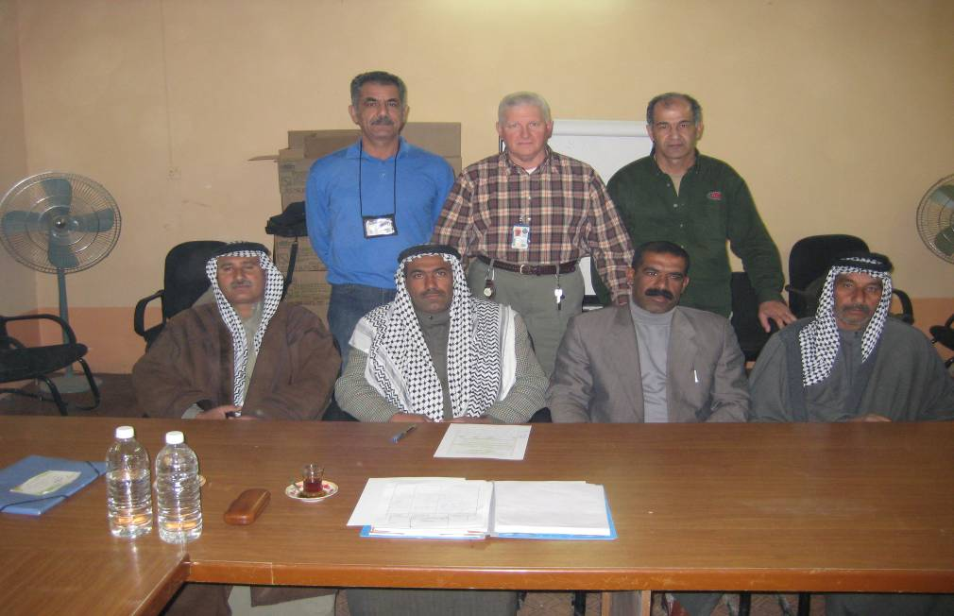

9. Market Site Photo

This photo shows the CEFM and agricultural center site (outlined in yellow) on Highway Tampa at “Checkpoint 17”.

10. Importance of the CEFM’s Location

Some older, traditional urban markets do exist some 20 to 25 km to the west and northwest of the site selected for the CEFM. But those markets are crowded and do not allow for facilities development or expansion. Neither are they centrally positioned along an easily accessible growth corridor such as Highway Tampa.

The transport of goods from the area’s Model Communities to more distant larger bulk sales markets in Baghdad or Kerbala has been a security problem in the past. Even under secure conditions, transport to those distant markets is time consuming and laborious. The AG Team learned in an interview with Umran Hassan, a progressive farmer from Muelha who lives just 3 km from the proposed new CEFM, that he must plan on 2 full days of travel to take a Bongo truck loaded with produce to market in Kerbala, wait there to sell the load “in bulk” at auction, and then return home.

In selecting the site for the CEFM, the participating AG Associations who made that decision took the following factors into consideration:

- First, although the CEFM and agricultural center will have its own guards for checking bulk-loaded trucks, the Highway Tampa ”Checkpoint “17” site allows for maximum additional security from Coalition Forces at FOB Kalsu and from both the Iraqi Army and Police who are located nearby.

- Second, the CEFM and agricultural center is being built for the future when security and economic growth prospects become a reality in Iraq. When that day arrives, rapid growth will occur along main two-lane corridors such as Highway Tampa.

- Third, a site central to the CEFM and agricultural center’s originating AG Associations’ production areas was desired, especially for Bongo truck bulk sales, and the Highway Tampa site met that standard.

- Fourth, the Highway Tampa site allows for nearly unlimited expansion of the CEFM and agricultural center facilities over time. Its central location between the Euphrates and the Tigris Rivers allows it to service both the originating AG Associations, bulk buyers, producers, and customers from surrounding areas, including Hilla to the South, Wasit to the East, Karbala and Najaf to the Southwest, and Dywaniah to the Southeast.

- Fifth, the Highway Tampa site allows for a Vet Clinic. Veterinarians employed by the CEFM will be affiliated with the Babil Provincial Veterinary Company and will perform both clinical services and public health work that focuses on food safety related to food borne hazards at the point of consumption.

- Finally, the Highway Tampa site allows for a Training Facility. Education programs at CEFM’s agricultural center will enhance the skills of area farmers and businessmen by providing courses in finance and accounting, business plans, project management, information technology and marketing strategies.

11. Market Construction Phases

The CEFM and agricultural center will be built in three (3) phases:

- Phase I will provide both bulk and stall selling areas, a meeting room to be used for training purposes, and additional basic support facilities.

- Phase II will add a veterinary clinic, livestock auction, grain storage for animal feed, and cold storage facilities for meats and perishable commodities.

- Phase III will add food chain value-added processing capabilities.

12. Estimated Cost of Market Phase I

A professional review of the Scope of Work for Phase 1 was conducted by an engineer and cost estimator who determined that its estimated cost is $2.8 Million.

13. General Layout of the Market Phase 1

This diagram shows the general concept of buildings and structures for bulk sales Phase I of the CEFM and agricultural center.

14. Marketplace Floor Plan Phase 1

This diagram shows the floor plan for the CEFM’s produce sales area.

15. Building Capacity in Phases

Over time, as the CEFM and the agricultural center’s marketing programs grow. Those programs will add economic capacity to the area and make it a focal hub for the transportation and sale of agricultural goods and services to and from surrounding areas. It shall also have connectivity to Iraq’s national commerce.

From CEFM Phase I, the area’s Model Communities will benefit from:

- an increase in agricultural business activity
- increased employment and new types of job opportunities
- agriculture extension experiments and educational projects.

CEFM Phase II will allow several veterinarians to treat animals in a modern onsite clinic, and to have increased responsibilities as public health officers who will examine animals pre-auction, inspect on-site slaughter and butcher facilities, and monitor the Market’s selling areas and its Café according to present day sanitary practices.

16. Value-Added Food Chain Processing in Subsequent Phases

Value-added food chain processing generally means manipulating a product in a way that increases its value or usability. These processes can involve changing a product into a different market form, or preserving, packaging or labeling it.

In time, the types of value-added processing that CEFM Phase III will provide include:

- Vegetable premium quality selection and packaging, and jarred pickles;

- Grain and Oilseed processing of ground and packaged flour; baked breads; bagged rice; packaged rice stuffing mixtures; packaged confectionary sunflower seeds; bottled or canned sesame seed cooking oil;

- Meat and Poultry processing of beef and lamb premium cuts, packaged sliced meat, packaged ground meat, packaged sausage and stew meats; packaged chicken parts; packaged kabob mixture and jerky; and cooked take-out kabobs and rotisserie chicken;

- Dairy Product processing of fluid cow’s milk, cow’s milk soft cheeses, hard cheeses, cottage cheese, yogurt, sour cream, ice cream and ice cream mix, butter; and goat’s milk soft cheeses;

- Honey, Wool and Mohair processing of glass packaged pasteurized honey, packaged comb honey, packaged baked baklava; shorn and cleaned wool and cashmere, tanned hides and cleaned pelts;

- Fruit processing of packaged fruit; processed dates and bottled date syrups; jarred jams, jellies and preserves; bottled or canned olive cooking oil;

- Fish filet processing, and packaging filets.

17. Training and Employment Opportunities during Construction

An agreement with the contractor who builds the Market will require them to teach unskilled laborers new skills. The economic study estimates that this contract training component will provide training opportunities and jobs for:

- 4 helpers for masons and bricklayers
- 4 electrician’s helpers
- 4 carpentry workers
- 4 plumber’s helpers

- 2 trainee fork-lift operators
- 2 trainee heavy equipment operators.

And after CEFM Phase 1 is completed and the bulk sales and stalls sales Market is functional, it is estimated that incentives created by the Market will lead to employment opportunities for:

- 20 guards at the Market
- 60 vendors at the Market
- 20 management and maintenance staffers at the Market
- 1000 farm workers who will harvest and deliver area produce to the Market.

18. Extension Programs and Experimentation

When Phase 1 of the CEFM is completed, agricultural center educational programs conducted in the meeting room, or on test plots behind the parking area, will involve:

- Extension Training Programs for modern, health conscious farm homemaking skills; proper and timely fertilizer and pesticide application; salinity control methods; water saving irrigation practices; best farming practices; farmland soils rehabilitation; farmland erosion control; and farmland preservation.

- Experiments for testing new seeds and hybrids; introducing new crops to the area; testing fertilizer and pesticide applications; studying yield maximizing techniques; implementing irrigation efficiencies; updating planting and harvesting methods; testing new soils preparations such as “no-till” farming.

19. Non-Sectarian & Non-Discriminatory Policies

As a centralized wholesale facility for local and distant produce, the CEFM and agricultural center will provide for non-sectarian distribution. This means trucks to larger distribution markets will not be identifiable to a specific community, tribe, or religious sect. The CEFM will also be non-discriminatory in that it shall provide shops to those who can afford to lease the space, while others less fortunate may use the Market’s wholesale services to sell their products.

20. Study Conclusions and Recommendations

The AG Team Concluded that in the north Babil Province area:

- there is no central bulk sales wholesale-retail market, or marketing strategy

- farmers and AG Associations have very limited access to financing for agribusiness ventures

- there is a serious problem regarding affordable inputs such as seed, fertilizer, pesticide, and animal feed prices are very high

- farmers lack modern farm equipment and processing technology; much of the equipment is more than 50 years old and there is a shortage of spare parts

- there are both serious water and salinity-buildup problems, that in some cases involve poor drainage, and in other instances involve clogged canals, no water, or the need for using modern spray irrigation systems

- animal wealth is diversified, is a significant current source of income, and it has potential for real growth given incentives such as the CEFM, see Part III, Supply Table Number 4

- there is a significant agricultural supply-demand imbalance, evidenced by:

- year round, only 16.36 percent of the tillable land of the participating AG Associations is planted to vegetables, see Part III, Supply Table Number 1

- year round, 14.80 percent of the tillable land of the participating AG Associations is used to produces fruit, see Part III, Supply Table Number 3

- the North Babil area’s greatest demand is for barley, wheat, yellow corn and (dairy) milk, however, far less than half of these needs are produced by area farmers, see Part III, Chart X

- during the winter season, much of the tillable land of the participating AG Associations is planted to wheat that returns poor, State-determined, prices to area farmers, see Part III, Supply Table Number 2

- milk (dairy) production by the participating AG Associations is only 39 percent of the area’s needs, yet it has potential for growth, see Part III, Chart X.

The AG Team Recommends an AG Strategy, to be associated with the CEFM and its training programs, that focuses on reconstructing and improving the area’s agricultural productive capacity according to these priorities:

- developing better marketing facilities and short-long term marketing strategies
- providing farmers and AG Associations with funding sources for agribusiness
- providing affordable sources of farm equipment
- implementing modern, efficient spray irrigation systems
- providing affordable sources of farm inputs such as seed, fertilizer, pesticides
- providing affordable sources of feed for chicken and livestock operations
- increasing the area’s year round vegetable production
- providing sources of plastic and framing for winter farming operations
- providing milk collection and processing centers to revitalize area dairy farms.

Part III - Economic Data in Tables and Charts

See separate document of Excel tables and charts the accompanies this paper.

Addendum 1

MEMORANDUM OF AGREEMENT
FOR THE ESTABLISHMENTG OF
CENTRAL EUPHRATES VALLEY
FARMERS' MARKET

1. Introduction

The undersigned Agricultural Associations of northern Babil Province and the United States Government representatives (together the parties) agree to collaborate in establishing the Central Euphrates Valley Farmers’ Market, as described herein.

The objectives of the Central Euphrates Valley Farmer’s Market is to enable Agricultural Association Model Communities to take a proactive and cooperative intercommunity leadership role to enhance the agricultural economic sector, engaged in positive, community building and “local pride” The program can grow to become a focal hub for transportation of agricultural goods and services to and from surrounding areas and connectivity to national commerce. Communities and surrounding areas will be granted business, employment, and agricultural extension opportunities currently unavailable to them.

2. Responsibilities of the Parties

A. Agricultural Association commit to:

- Each obtaining Nongovernmental Organization status through the Ministry of Nongovernmental Organizations as a prerequisite to inclusion in this project.

- Identifying, negotiating, and purchasing the real estate necessary for the Market, in a location agreed upon by all Agricultural Associations involved, Coalition Forces, and Iraqi Security Forces.

- Management of the Market as a business partnership that will provide opportunities for Agricultural Association members to sell their products in the market.

- Adopt and implement transparent business practices.

- Create a Management Board that will consist of elected members of each Agricultural Association Board.

- Employ operations and maintenance personnel for the Market and ensuring that personnel will be trained.

- Employ veterinarians for the operation of the veterinary clinic and inspection ands sanitary audits of the live animal auction, butcher facilities, and any store where food items or live animals are sold. These veterinarians will act in accordance with the Babil Province Veterinary Company and the laws of the Government of Iraq.

- Provide security for the Market in accordance with the laws of the GOI and in collaboration with the Iraqi Security Forces and Coalitions Forces.

  - United States Government representatives will commit to:

1) Assist and advise on identifying the financial sources necessary for establishing the Market

3. United States Government Specific Provisions

No Obligation of Funds. Nothing in this MOA shall be construed as an obligation or commitment of the United States Government funds. All United States Government responsibilities shall be carried out under separate agreement with the United States Government implementing partners.

Availability of Funds. All United States Government responsibilities under this MOA are subject to: (i) availability of funds; and (ii) agreements between the United States Government and its implementing partners regarding the provision of assistance under this MOA.

Compliance with United States Laws and Regulations. United States Government representatives shall obligate, commit, and expend funds and carry out obligations pursuant to this MOA only in accordance with the applicable laws and regulations of the United States.

Publicity. The Parties will give appropriate publicity to the assistance as a program to which the United States Government has contributed.

Ongoing Operations. The United States Government is not responsible for the continued support and financing of the Market after it has been constructed.

4. GENERAL PROVISIONS

Authorized Representatives. The Parties shall be represented by those holding or acting in the offices held by the signatories to this MOA. Each Party may, by written notice, to the other, identify additional representatives authorized to represent that Party for all purposes other than executing formal amendments to this MOA.

Amendment and Modification. This MOA may be amended or modified by written agreement by the Authorized Representatives of each of the Parties.

Suspension and Termination. Either Party may suspend or terminate, in whole or in part, the provision of assistance under this MOA, effective immediately upon notice to the other Party, if one Party determines in good faith that:

- the other Party failed to comply wit the provisions of this MOA;
- facts have arisen which make the achievement of purposes of this MOA improbable;

- the Parties will not be able to comply with provisions of this MOA;

- the provision of assistance under this MOA will result in violation of United States law or regulations or Iraqi law, or;

- funding for the assistance is unavailable.

In the event of partial suspension or termination, such notice shall specify the affected activities.

Language. This Memorandum is prepared in both Arabic and English. In the event of ambiguity or conflict between the versions, the English language version will control.

Effective Date. This MOA shall be effective when signed by the parties.

Addendum 2

Northern Babil Province Planting and Harvest Dates*
Commodity |  |  | Planted | Harvested
Vegetables | Winter  Grown Under  Plastic  Except Potatoes  Lettuce  R Beans | Eggplant | October | April
Vegetables |  | Peppers | October | April
Vegetables |  | Cucumbers | December | February
Vegetables |  | Zucchini | October | January
Vegetables |  | Tomatoes | October | December
Vegetables |  | Potatoes (Field) | October | January
Vegetables |  | Lettuce (Field) | September | March
Vegetables |  | Roman Beans (Field) | October | March
Vegetables | Summer  Grown In the Open Field | Eggplant | March | June
Vegetables | Summer  Grown In the Open Field | Peppers | March | June
Vegetables | Summer  Grown In the Open Field | Cucumbers | August | December
Vegetables | Summer  Grown In the Open Field | Zucchini | April | June
Vegetables | Summer  Grown In the Open Field | Tomatoes | February | August
Vegetables | Summer  Grown In the Open Field | Okra | March | June
Vegetables | Summer  Grown In the Open Field | Green Beans | March | May
Vegetables | Summer  Grown In the Open Field | Potatoes | February | May
Grains  Oilseeds  Grasses | Wheat |  | November | June
Grains  Oilseeds  Grasses | Barley |  | November | May
Grains  Oilseeds  Grasses | Oats (Double Cropped) |  | Mar & Sept | June & Dec
Grains  Oilseeds  Grasses | Sesame Seeds (Double Cropped) |  | Mar & Sept | June & Dec
Grains  Oilseeds  Grasses | Yellow Corn (Sweet) |  | August | December
Grains  Oilseeds  Grasses | Feed Corn |  | August | December
Grains  Oilseeds  Grasses | Cotton |  | Not Grown in northern Babil Province
Grains  Oilseeds  Grasses | Rice |  | Not Grown in northern Babil Province
Grains  Oilseeds  Grasses | Alfalfa |  | One Planting Lasts 3 Years
Fruit | Watermelon |  | Mid March | Mid May
Fruit | Honeydew Melon |  | Mid March | Mid May
Fruit | Cantaloupe |  | Mid March | Mid May
Dates | In Flower |  | Spray Time | Harvest
Dates | March |  | April & May | Sept, Oct, Nov
* Data from 3-27-08 interview with farmer Umran Hassan, Muelha, Babil Province.

Addendum 3

Persons Interviewed During This Economic Study
AG Association | Person Interviewed | Position | Tribes in Association’s Area
Al WaHaa  (Muelha) | Umran Hashim Hassan | Chairman | - Al Juboori  - Al Janabi  - Al Masoudi  - Al Ghirtani  - Bani Saad
Al WaHaa  (Muelha) | Khudair Unayed Al Janabi | Vice President
Al WaHaa  (Muelha) | Khudair Aliwi Al Jubori | Treasurer
Al WaHaa  (Muelha) | Ibraim Bedaiwi Hassan | Secretary
Al WaHaa  (Muelha) | Hussein Abid Ali | Board Member
Al Reef  (Jiff Jaffa) | Turky Salman Hijel | Chairman | - Al Juboori  - Al Masoudi  - Al Khafaji  - Al Greaat Bani  - Temeemi
Al Reef  (Jiff Jaffa) | Hamid Merza Hatrosh | Vice President
Al Reef  (Jiff Jaffa) | Sayeed Hussein Alwan | Treasurer
Al Reef  (Jiff Jaffa) | Kabdil Shyaa Abdil Hussein | Secretary
Al Reef  (Jiff Jaffa) | Basim Abdul Amer Abdullah | Board Member
Sheik Taha  (Al Haq) | Ismail Dayih | Chairman | - Al Janabi  - Al Juboori  - Al Masoudi  - Bani Ajeel  - Al Jorani  - Muhaimraa
Sheik Taha  (Al Haq) | Fadel Kudair | Vice President
Sheik Taha  (Al Haq) | Ahmed Abbas Ahmed | Treasurer
Sheik Taha  (Al Haq) | Ziyad Taha | Secretary
Sheik Taha  (Al Haq) | Mahdi Muhsin Munir | Board Member
Al Baraka  (Diyarah) | Jasim Mohammed Muhsin | Chairman | - Al Janabi  - Al Sultan  - Al Khafaji  - Al Jubori  - Al Khazraj  - Albo Ajeel  - Al Gharan  - Al Ubaid  - Al Echaish  - Al Esar
Al Baraka  (Diyarah) | Hatem Hasoon | Vice President
Al Baraka  (Diyarah) | Marzook Ehraiz | Treasurer
Al Baraka  (Diyarah) | Nasir Madloom Muhammed | Secretary
Al Baraka  (Diyarah) | Rashid | Board Member

